**SQL database**

1. Create server and database from portal. You can use below program to access the data (only select query). This data will be visible on localhost. 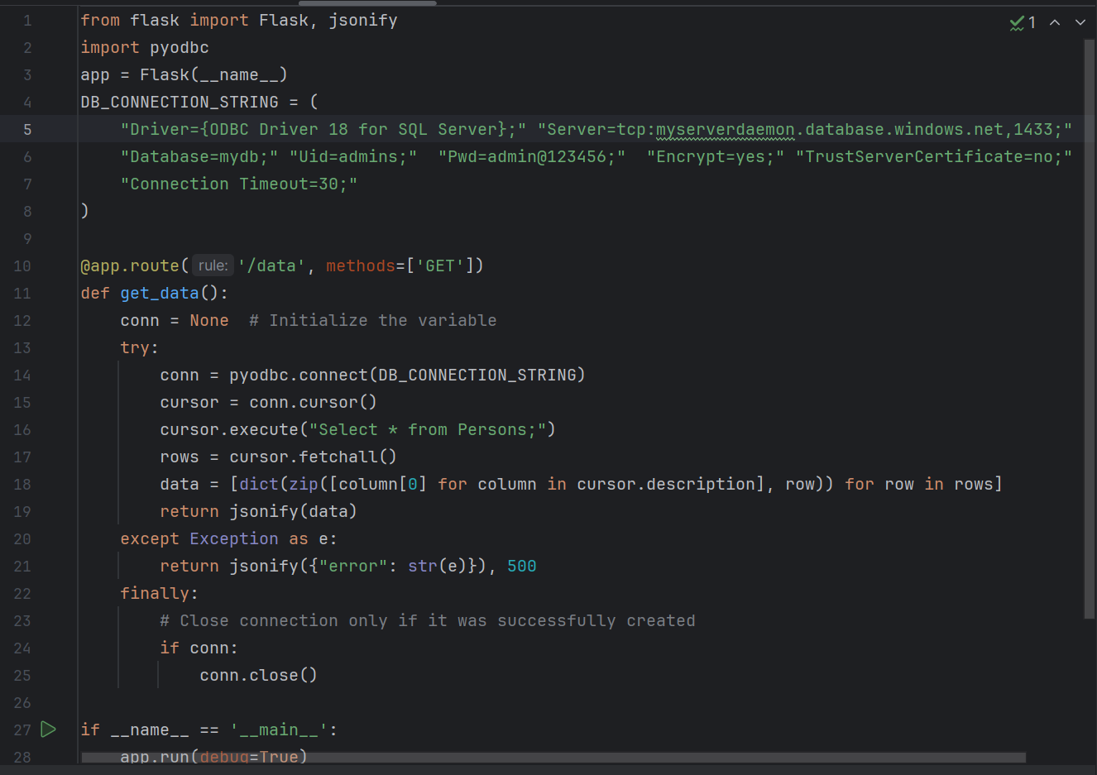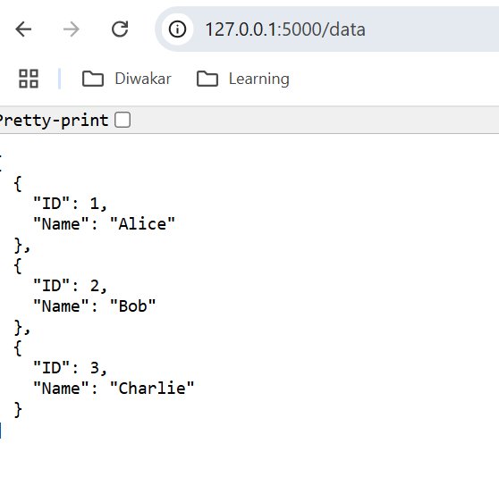
2. You can add the data to the database from Query editor on the portal. 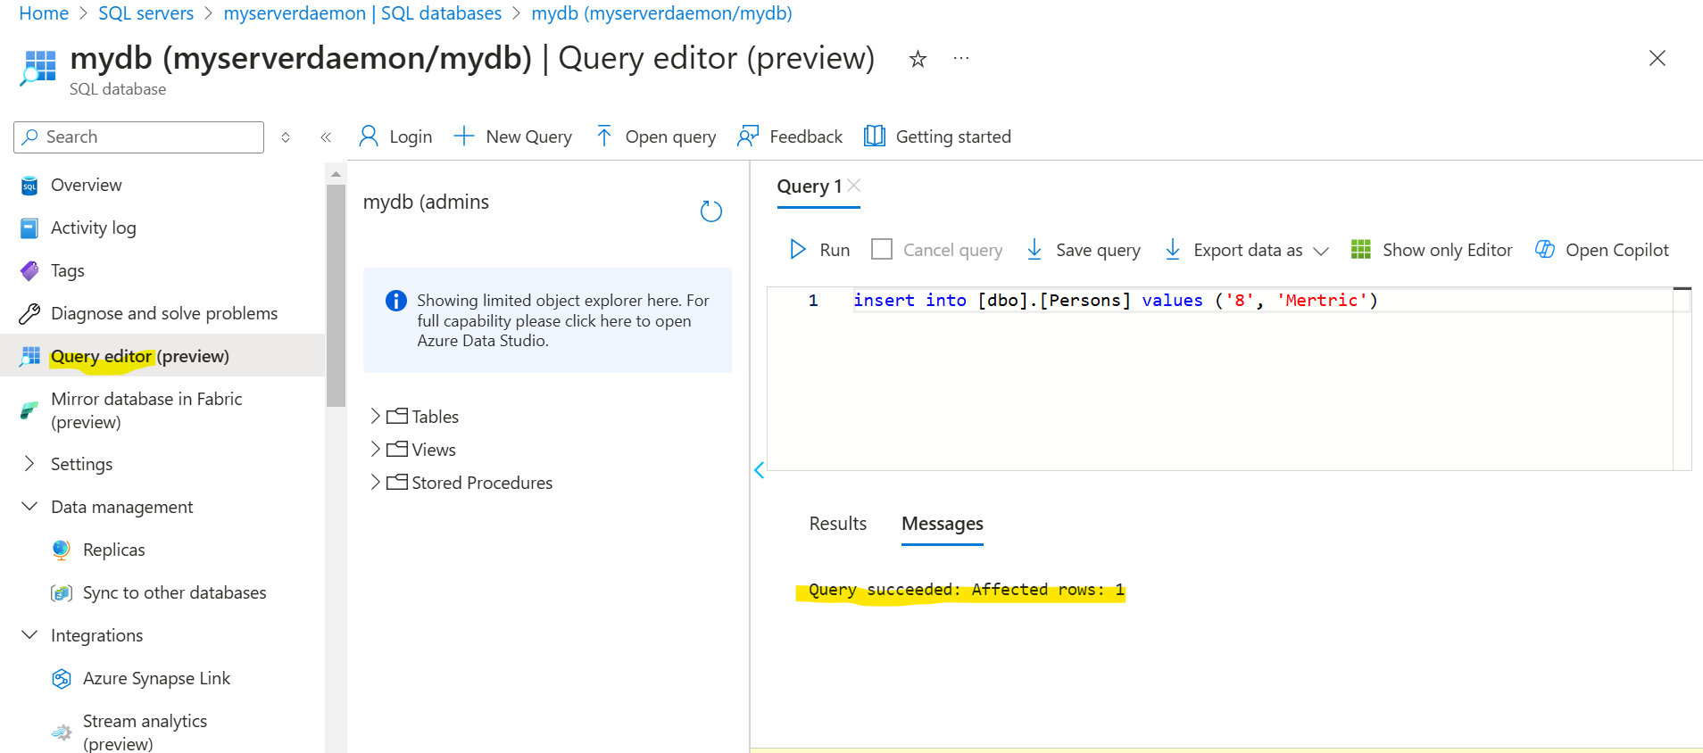
3. You can create replica from the replicas section, where you can create another database (in different server). The data would automatically synch. 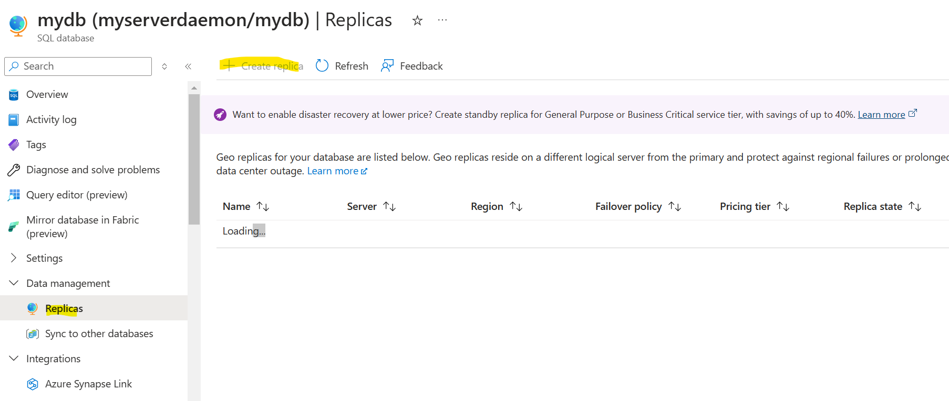
4. You cannot insert/delete/update anything in replica database as it is read-only. 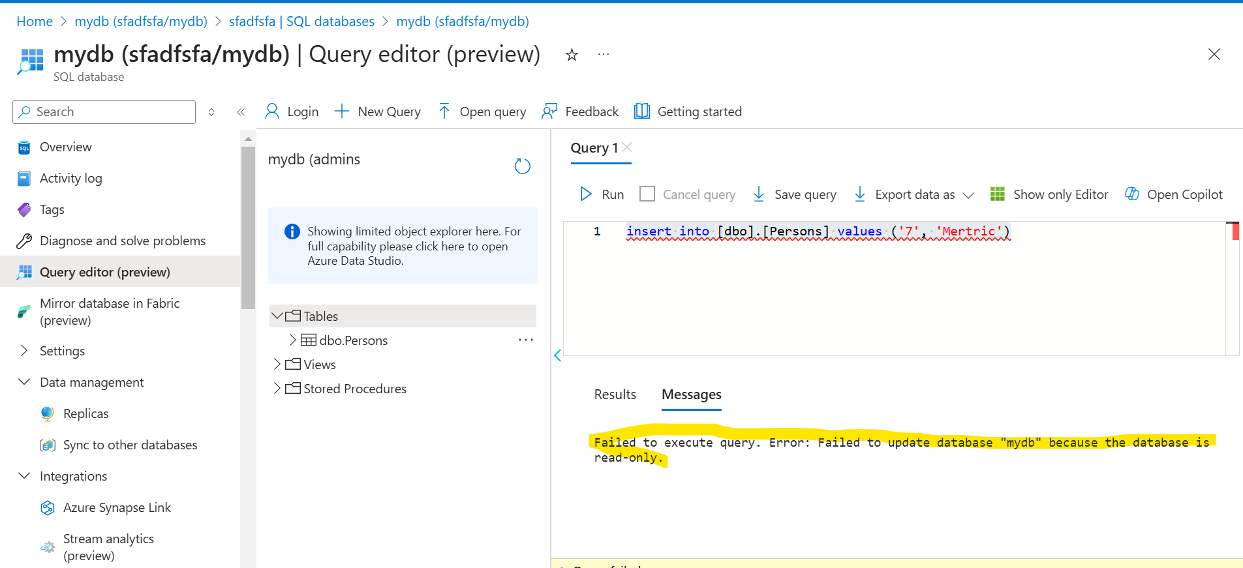 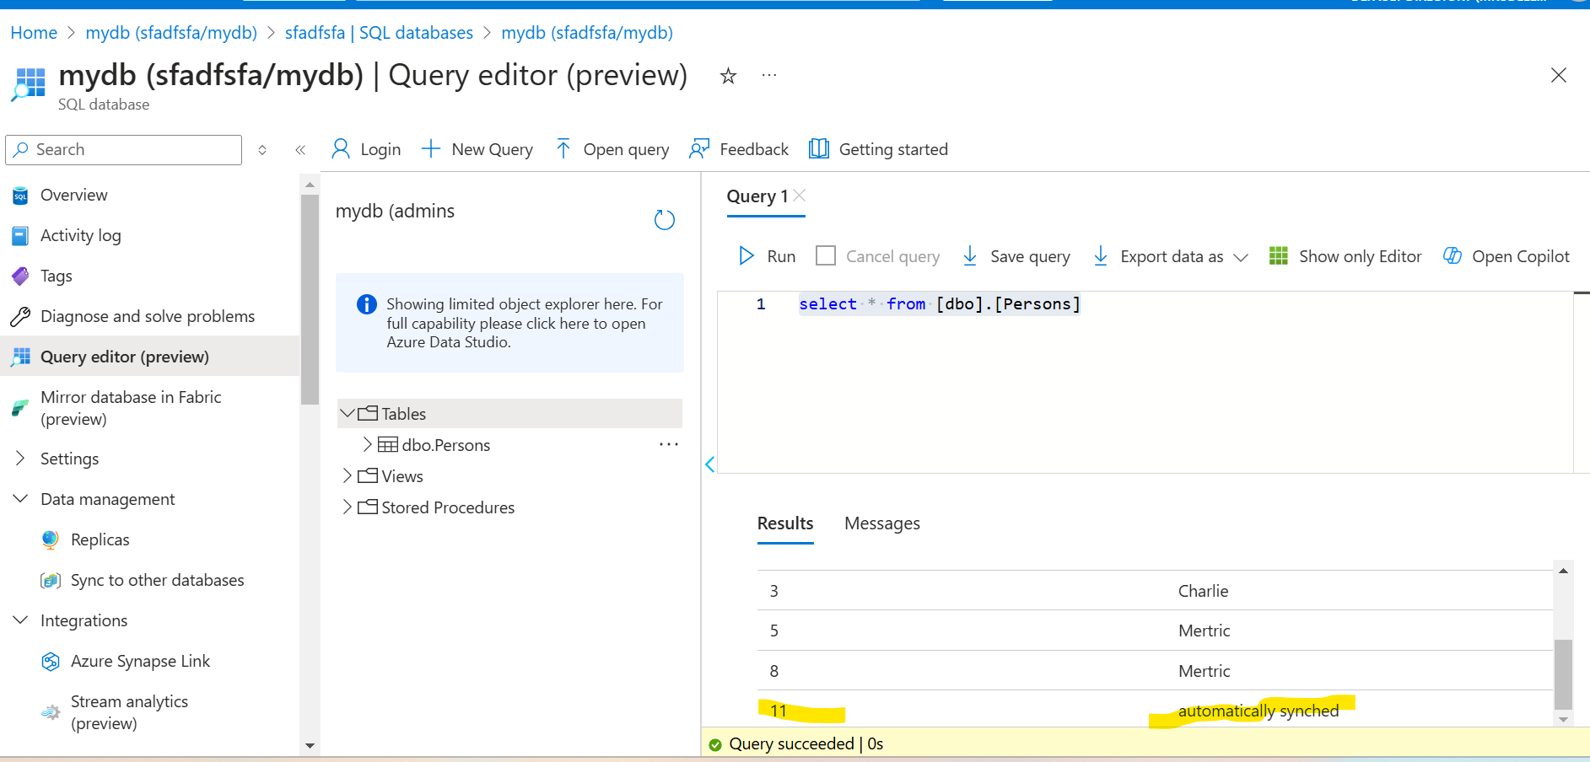
5. You can manually trigger failover from replica section of DB. 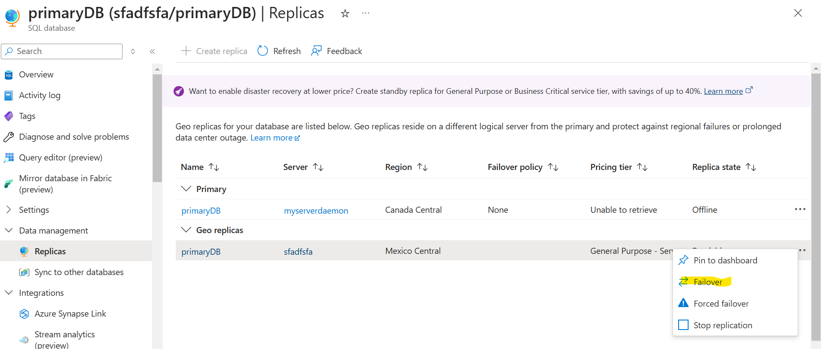
6. Remember the above step was on DB level. There is also another option of failover group, which protects the complete server. So what’s the difference between replicas and failover group? So, the replicas are just there to replicate, in case of any disaster it will not directly switch! You would have to manually switch between the databases. But when you create a failover group and add the replica in that fail over group, then in case of disaster, the db would be switched automatically. And all the traffic would be routed to the replicated db.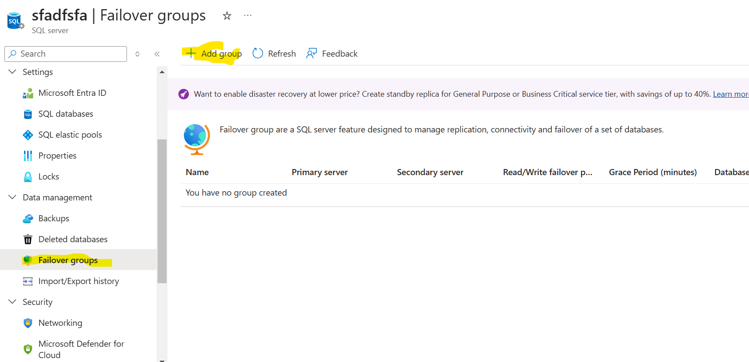
7. You can also the export the data to a storage account and see the percentage of export operation in the server import/export tab. Make sure the storage container should not have private access. Also, since the Azure portal doesn’t natively support importing data directly from Excel into SQL Database, the easiest way is to use **Azure Data Factory** to automate the data import process. 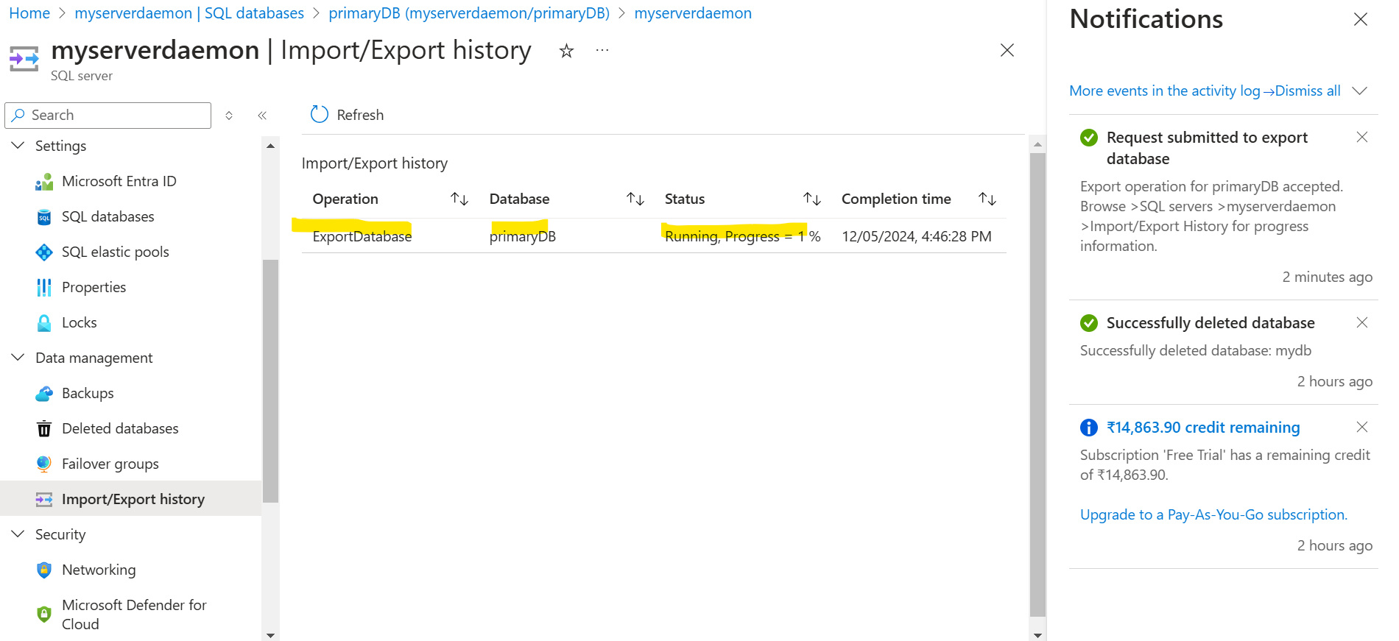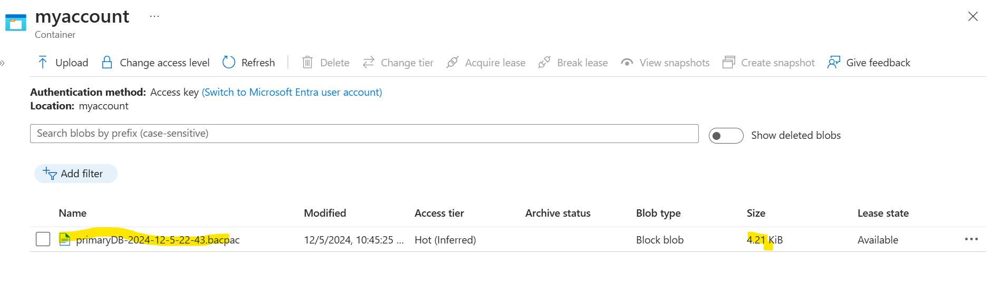
8. You can use this bacpac file to import it into new database using portal. 